Full Name: Rizwan Aiyaz Hassan

Age: 14

Grade: 9

Location: Riyadh, Saudi Arabia

Project Objective and Purpose: My aim for VoiceVibes is for it to help in detecting emotions of the user, a speech to text sub-section for people with hearing impairments, and a text to speech sub-section for people with visual disabilities.

Project Description: Voice Vibes can do many things. Voice Vibes was made by me with the help of my trainer. I used Jupyter Notebook to create the code. Voice Vibes has 3 parts to it. The first is emotion recognition, recognizing the sentence given as either “Positive”, “Neutral”, or “Negative”. The second is a sub-section for both Speech to Text conversion and a Text to Speech part as well.

Libraries needed for installation: tkinter, gtts, speech_recognition, os, vaderSentiment (“pip install ____” to install library)

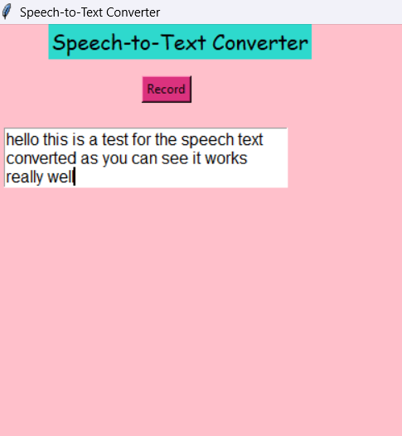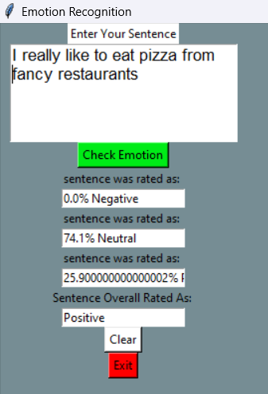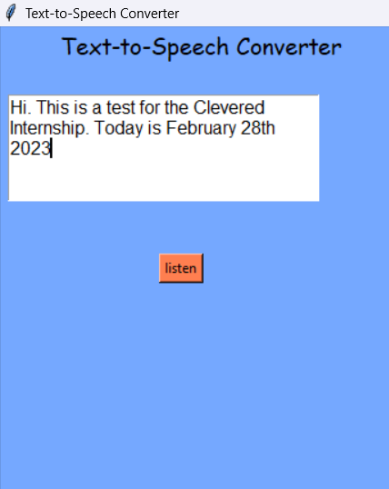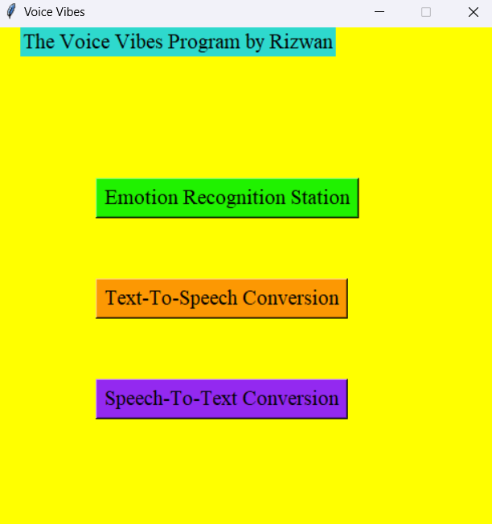Screenshots of the VoiceVibes Interface:

Speech to Text convertor

Text to Speech convertor

Emotion Recognition Station

Main Menu/ Starting Page

Photograph of Student: